Make 4: GIF & Remix Culture
Student Name: Natan Costa Oliveira da Silva
Title: Fully Charged
Tools Used: ChatGPT (concept development and GIF creation), Python/PIL (frame creation and GIF export)

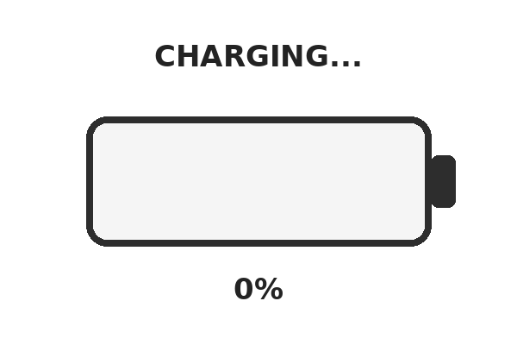

The Artifact (Description)
The GIF shows a battery charging from 0% to 100%. The battery begins almost empty and red, then gradually fills while changing colors from red to orange, yellow, and finally green. The percentage also changes as the battery fills. When the battery reaches 100%, the words “FULLY CHARGED!” appear. The animation then loops continuously, creating a repeated charging cycle.
The GIF uses 15 frames so that the movement from one charging level to the next feels smooth. The battery is centered on a simple white background so that the changing colors and percentage are easy to see.

Reflection (≈250 words)
Creating this GIF made me think about how a very simple visual can communicate an idea through repetition. A battery charging is something that I see regularly on computers and phones, so the image is immediately familiar. However, turning it into a repeating animation changes how I experience it. Instead of simply showing a battery at one moment, the GIF creates a cycle that keeps starting over.
The color changes are also important to the meaning of the animation. Red represents a low battery, while the colors gradually move through orange and yellow until reaching green at 100 percent. The green battery and the words “FULLY CHARGED!” create a sense of completion, but the GIF does not actually stay completed. It starts charging again. This makes the loop itself an important part of the work.
The simplicity of the GIF was intentional. I wanted to use a familiar digital symbol and change the way it is experienced through animation and repetition. The battery is normally a functional interface element that tells us how much power remains. In this GIF, it becomes something we repeatedly watch, turning a practical symbol into a visual loop.
This project also helped me understand why repetition matters in GIF culture. The animation does not need a complicated story or many visual elements. The repeated movement is enough to create meaning. The viewer watches the battery reach completion and then immediately sees the process begin again, making the idea of an endless charging cycle the main focus of the GIF.

Attribution & AI Use
● AI Tool Used: ChatGPT
● How AI Was Used: Helped develop the concept, plan the animation, and create the GIF structure
● What the AI Generated: The 15-frame battery charging animation
● What I Changed or Remixed: Selected the charging sequence, color progression, percentage levels, timing, layout, and looping behavior
● Additional Tools: Python/PIL for creating and exporting the GIF

